* **Registration Form page**

<head>

<title>Online Mobile Shopping</title>

</head>

<body bgcolor="pink">

<h1><head><p style= "background-color:blue; font-family:Arial; text-align:center;">

Mobile Store</p></head></h1>

<img src="mobile.jpg" width="900" height="600" align="left" vspace="25">

<form method="Post" action="dataprocess.asp">

<table border="1" align="right" width="400" height="500" bgcolor="cyan" >

<caption><b>Registration form</b></caption><br>

<tr>

<th>Enter your first name</th>

<td><input type="text" name="fn" maxlength="20" </td>

</tr>

<tr>

<th>Enter your last name</th>

<td><input type="text"/></td>

</tr>

<th>Enter your email</th>

<td><input type="email"/></td>

</tr>

<tr>

<th>Enter your password</th>

<td><input type="password"/></td>

</tr>

<tr>

<th>ReEnter your password</th>

<td><input type="password"/></td>

</tr>

<tr>

<tr>

<th>Enter your mobile</th>

<td><input type="number" maxlength="10"/></td>

</tr>

<tr>

<th>Enter your address</th>

<td><textarea rows="8" cols="20"></textarea></td>

</tr>

<tr>

<th>Select your gender</th>

<td>

male<input type="radio" name="g" value="m"/>

female<input type="radio" name="g" value="f"/>

</td>

</tr>

<tr>

<th>Select your DOB</th>

<td><input type="date"/></td>

</tr>

<tr>

<th>Select your Country</th>

<td>

<select name="country">

<option value="" selected="selected" disabled="disabled">Select your country</option>

<option value="1">India</option>

<option value="2">Pakistan</option>

</select>

</td>

</tr>

<tr>

<td colspan="2" align="center"><input type="submit" value="Submit"/>

<input type="reset" value="Reset"/>

</td>

</tr>

</table>

</form>

</body>

</html>

**Output:-**

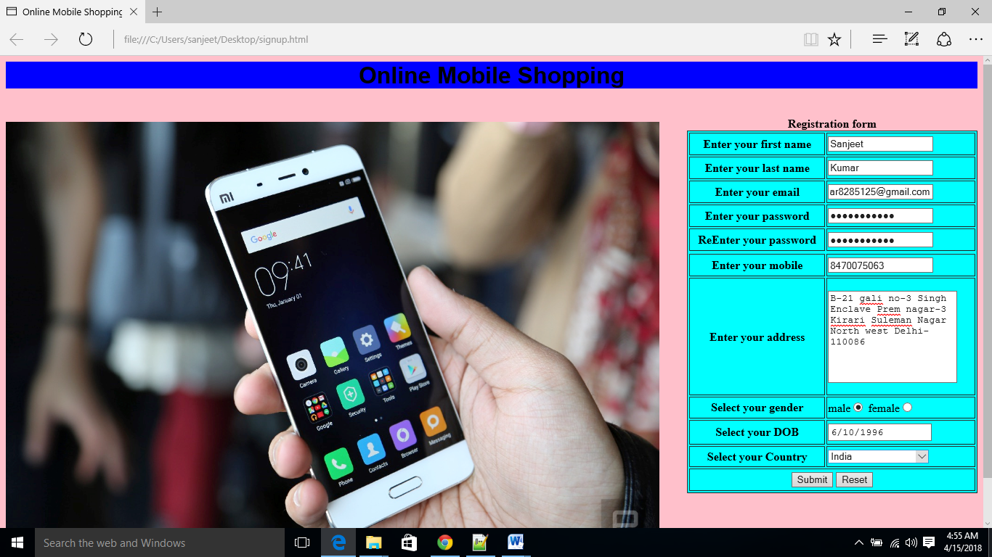

* **Login Form page**

<head>

<title>Login Form</title>

</head>

<body bgcolor="Pink"back>

<h1><head><p style= "background-color:blue; font-family:Ariel;color:white;text-align:center;">

Welcome to online mobile Store</p></head></h1>

<img src="Image3.jpg" width="900" height="600" align="left" vspace="10">

<form method="Post" action="dataprocess.asp">

<form>

<table align="right" width="350" height="150" border="1" bgcolor="Green">

<caption><b>Login form</b></caption><p>

<tr>

<th>Enter your Email id</th>

<td><input type="email"/></td>

</tr>

<tr>

<th>Enter your passowrd</th>

<td><input type="password"/></td>

</tr>

<tr>

<th colspan="2"><input type="submit" value="SignIn"/>

<a href=signup.html>SignUp</a></th>

</tr>

</table>

</form>

</body>

</html>

**Output:-**

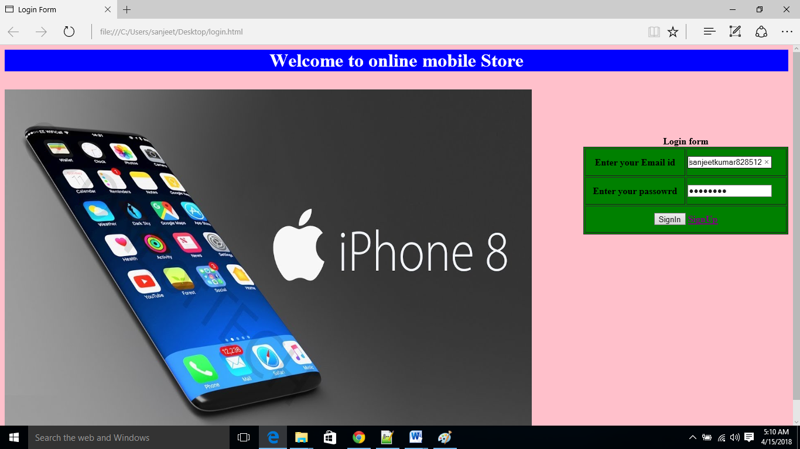

* **Home page**

<html>

<title> Home Page</title>

<body bgcolor="grey" size="20">

<p><br>

<h1><head><p style= "background-color:green; font-family:Arial ;color:white; text-size:20px;">

!!!!Online Mobile Shopping!!!!

<input type="Text" name="S" value="Search" size="40" maxlength="25">

<input type="Button" name="Go" value="Go">

View Profile

<input type="Button" value="cart">

<a href=login.html>LogIn</a>

<a href=homepage.html>Logout</a></p></head></h1>

<table border="3" >

<tr>

<td width=300 height=700 bgcolor=Cyan font-size="16">

<img src="baby.jpg" width="30" height="30" border="3">

Sanjeet Kumar<br>

Edit Profile<br><br>

<h3>Shop By Category</h3>

Nokia<br><br>

Samsung<br><br>

Xiaomi<br><br>

Oppo<br><br>

Vivo<br><br>

Apple<br><br>

Gionee<br><br>

Huweai<br><br>

lenevo<br><br>

Lava<br><br>

Micromax<br><br>

Sony<br><br>

Jio<br><br>

Intex<br><br>

Asus<br><br>

</td>

<td width="550" height="700" bgcolor="Pink">

<center>

<h2>Select Mobiles</h2><br>

<img src="Vivo9.jpg" width="180" height="180" border="3"><br>

Vivo V9 Plus<br>

Rs 20000<br>

<input type="Submit" name="cart" value="Add To Cart"><br><br>

<img src="nokia6.jpg" width="180" height="180" border=3><br>

Nokia 6 (Matte Black, 32GB)<br>

Rs 12000<br>

<input type="Submit" name="cart" value="Add To Cart"><br><br>

<img src="honor7x.jpg" width="180" height="180" border=3><br>

Honor 7X (Black, 4GB RAM + 32GB memory)<br>

Rs 12999<br>

<input type="Submit" name="cart" value="Add To Cart"><br><br>

</center>

</td>

<td width="550" height="700" bgcolor="teal">

<center>

<img src="iphonex.png" width="180" height="180" border="3"><br>

Apple iPhone X (Silver, 256GB)<br>

Rs 97999<br>

<input type="Submit" name="cart" value="Add To Cart"><br><br>

<img src="mimix2.jpg" width="180" height="180" border="3"><br>

Mi Max 2 (Black, 64 GB)<br>

Rs 97999<br>

<input type="Submit" name="cart" value="Add To Cart"><br><br>

<img src="oppo.jpg" width="180" height="180" border="3"><br>

Oppo F5 (Black, Full Screen Display, 6 GB RAM)<br>

Rs 24990<br>

<input type="Submit" name="cart" value="Add To Cart"><br><br>

</center>

</td>

</tr>

</table>

</html>

**Output:-**

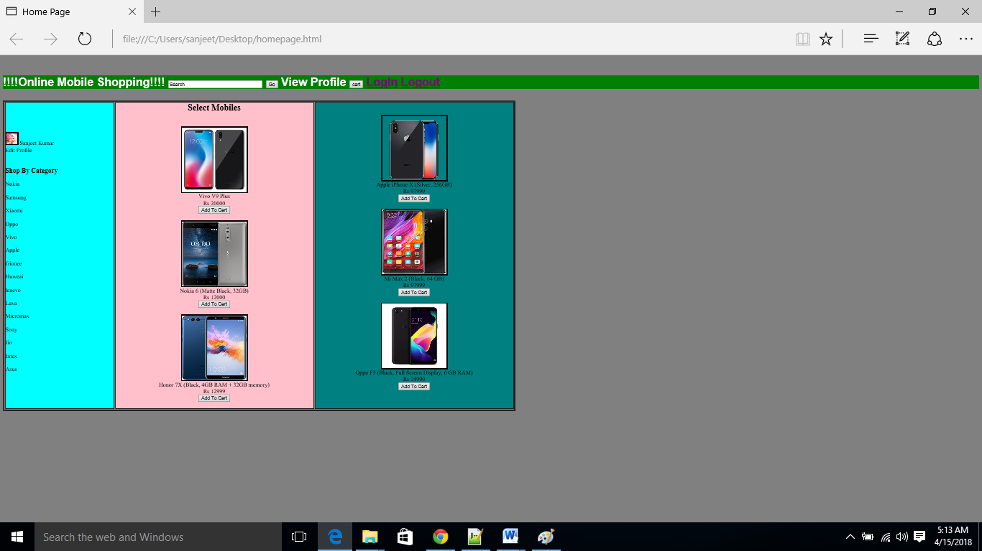

* **Shopping Cart**

<body bgcolor="aqua" text="Arial">

<h1><head><p style= "background-color:green; font-family:Arial ;color:white;text-size:20px;">

Your Shopping Cart</p></head></h1>

Shopping Cart

<table border="2" height="50%" Width="50%" cellspacing="2"bgcolor="Pink">

<tr>

<th>Quantity</th>

<th>Item</th>

<th>Order Code</th>

<th>UnitPrice</th>

<th>Total</th>

</tr>

<tr>

<td>

<center>

<input type="Button" value="2"></td>

</center>

<td>

<center>

<img src="Vivo9.jpg" width="100" height="100" border="3"><br>

Vivo V9 Plus

</center>

<td><center>vivo12123<center></td>

<td><center>Rs 20000</center></td>

<td><center>Rs 40000</center></td>

</tr>

<tr>

<td>

<center>

<input type="Button" value="1"></td>

</center>

<td>

<center>

<img src="iphonex.png" width="100" height="100" border="3"><br>

Apple iPhone X (Silver, 256GB)

</center>

<td><center>iphonex76761<center></td>

<td><center>Rs 97999</center></td>

<td><center>Rs 97999</center></td>

</tr>

<tr>

<td>

<center>

<input type="Button" value="3"></td>

</center>

<td>

<center>

<img src="oppo.jpg" width="100" height="100" border="3"><br>

Oppo F5 (Black,FullScreen Display,6GB RAM)

</center>

<td><center>oppodfg43<center></td>

<td><center>Rs 24990</center></td>

<td><center>Rs 74970</center></td>

</tr>

<tr>

<td>

<center>

<input type="Button" value="2"></td>

</center>

<td>

<center>

<img src="honor7x.jpg" width="100" height="100" border="3"><br>

Honor 7X (Black, 4GB RAM + 32GB memory)

</center>

<td><center>Honor7x99811<center></td>

<td><center>Rs 12999</center></td>

<td><center>Rs 25998</center></td>

</tr>

</table>

<input type="Submit" value="Confirm Order">

<input type="Submit" value="cancel">

</body>

</html>

**Output:-**

